Preparation
Description | This activity will help you get started with Git. You will work on a remote repository shared by other classmates.
Source | Assignment adapted from POSSE Git Assignment
Prerequisite Knowledge | A rudimentary understanding of command-line usage would be helpful, but not required.
Estimated Time to Completion | 30-60 minutes
Learning Objectives | Upon completion, you will be able to  - Install Git.  - Configure Git.  - Clone a GitHub repository.  - Make changes to a repository.  - Commit changes to a GitHub repository.
Materials/Environment | - Access to Internet/Web and web browser
Additional Information | - Git website: http://git-scm.com  - Repository location: https://github.com/beckamorgan/CS477-577
Rights | Licensed CC BY-SA (?)
Turn In | Your information added to a shared repository. Blog posting describing the results of your exploration below.

Background
Version contol is vital for maintaining code that is developed by a group and is especially important when that group is non-colocated. After watching the videos you should have a pretty good idea of what version control is, what it can do, and why it is so powerful.

Git Assignment

Step one:
Go to GitHub and create an account ( github.com )
After you create your GitHub account you will find my repository by typing beckamorgan/CS477-577
in the search box at the top of the page. Once you get to the page you should see:
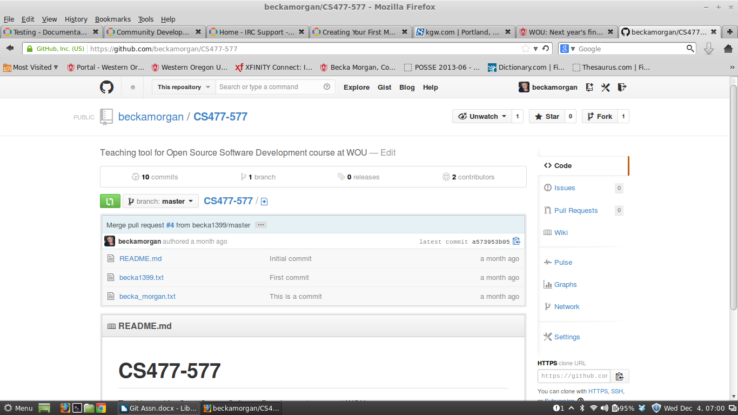
You want to click on fork. This will give you a fork of the repo in your own GitHub account.

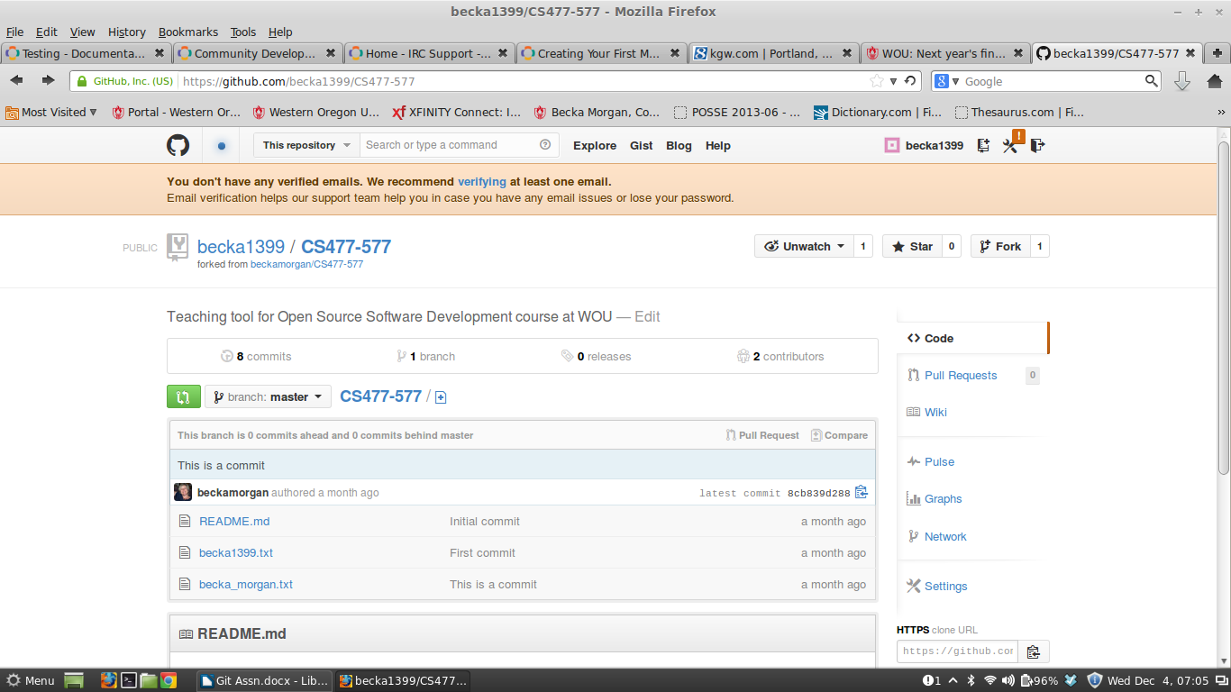
Note that I am now back in becka1399/C477-577 instead of beckamorgan/C477-577. We will use this fork in the next steps.

Step two:
We will be using the terminal to install git from the command line in Linux. To open the terminal go to Menu and you will see an icon in the left portion of the menu -
Click this icon to open the terminal.

- From the command line to install Git type:
$ sudo apt-get install git

- Then you need to configure Git for the first use:
http://git-scm.com/book/en/Getting-Started-First-Time-Git-Setup
$ git config –global user.name "yourname"
$ git config –global user.email "your email address"

Keep your editor and diff tool set to the default.
Check your configuration:

$ git config --list

Review 1.6 Getting Started - Getting Help

Step three:

- Cloning the class project:

$ git clone https://github.com/your_GitHub_username/CS477-577.git

- Change directory into the project you just cloned:

$ cd CS477-577 (Try typing cd C then hit the tab key. This will auto compete your directory name)

- To check your working directory type

$ git status

Note that your branch is called master and that it is a clean working directory.

- Create a text file in the terminal:

$ vim yourname.txt

This will open up a text document in the vim text editor. Type a message in this document. Hit the escape key to return the editor to command mode, then type :wq to save and exit the document. If you look in your CS477-577 folder you will see the file you just created.

$ git status

will show you that you now have an untracked file.

- Next we will add the file you created to the project. The first step is to track the file. To do this you use the add command:

$ git add yourname.txt

Run $ git status again. You will notice that your file is now considered a new file that has not been commited yet. This is reffered to having a file staged. To commit your changes you would enter:

$ git commit -m "This would be a message you would enter to explain the commit"
(The -m flag stands for message)

- At this point we need to know the name of the remote handle of the remote server we configured. To access this information type:

$ git remote

- Next you will push your file to the git server (push to origin my master).

$ git push origin master

- After you push your file to your GitHub account,go to the account and submit a pull request.
  - Click pull request
  - New pull request
  - Click to create a pull request for this comparison
  - Send pull request
Now it is up to the creator of the project to merge your file.

Final Step:
The last thing you will need to do is to fork the openMRS project.
https://wiki.openmrs.org/display/docs/Using+Git#UsingGit-Createaccountongithub.com
Get the code (with the intention of contributing changes). Step one only.

